

Name : Azaria Cindy Sahasika

Number Id : 2341760169 / 06

Class : 2G – Business Information System

Lesson : Object Based Programming

Github Link : <https://github.com/azariacindy>

1. Identify the following diagram classes, make complete improvements and in accordance with the rules for writing diagram classes.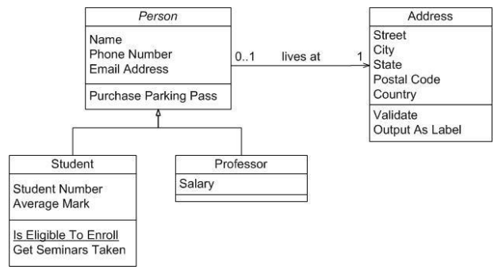

**Answer:**

The following diagram classes are in accordance with the diagram class writing rules.

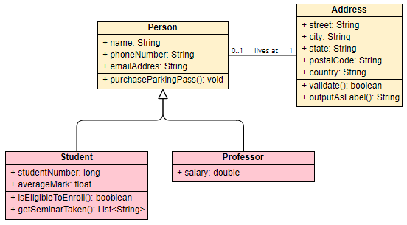

1. Create a class diagram that uses multilevel inheritance and code the program

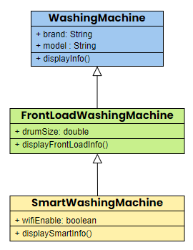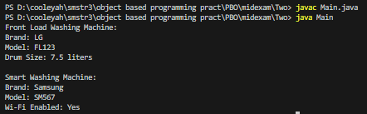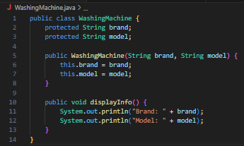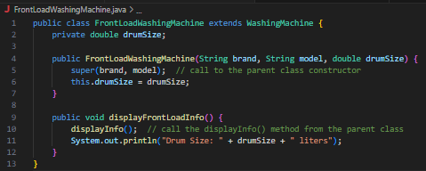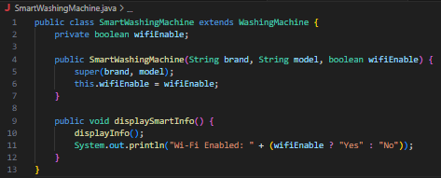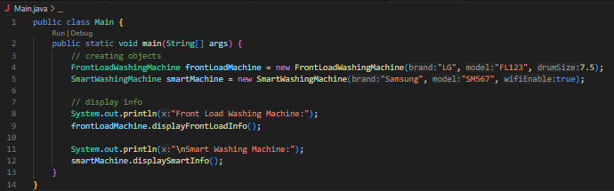

1. Identify the class diagram and explain the concept of inheritance, relationships between classes and the flow of the following system, create program code from the following class diagram.

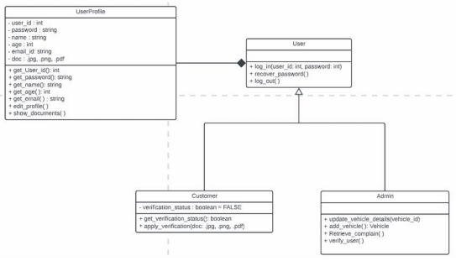

Here’s the program code:

